**Report on Python Functions and Code Logic**

* **Prompting User for Details**

**Approach**

We created a function named get_user_details to prompt the user for their name, age, email, and favorite number. We stored these details in a dictionary. We also created a function named validate_email to check if the email is in a valid format (contains "@" and "."). Finally, we created a function named display_message to print a message using the user's details.

**Logic**

* Prompt the user for their details and store them in a dictionary.
* Validate the email format using a regular expression.
* Print a message using the user details.
* **Checking Even or Odd Numbers**

**Approach**

We created a function named Is_even to determine if a number is even or odd. The function takes an integer as input and checks if it's divisible by 2. If it is, the function prints that the number is even and returns True. Otherwise, it prints that the number is odd and returns False.

**Logic**

* Use the modulus operator % to check if the number is even.
* Print a message stating whether the number is even or odd.

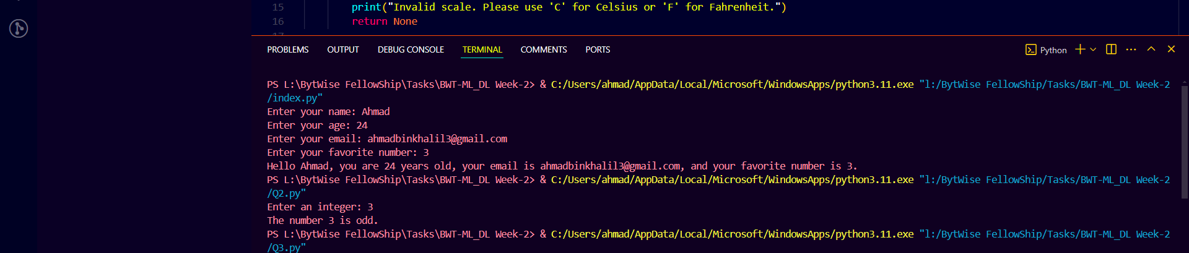

* **Temperature Conversion**

**Approach**

We created a function named convert_temperature to convert temperatures between Celsius and Fahrenheit. The function takes a temperature value and a scale ("C" or "F") as inputs. It converts the temperature to the other scale and returns the converted value.

**Logic**

* If the input scale is "C", convert the temperature to Fahrenheit using the formula (temp×95)+32(temp \times \frac{9}{5}) + 32(temp×59​)+32.
* If the input scale is "F", convert the temperature to Celsius using the formula (temp−32)×59(temp - 32) \times \frac{5}{9}(temp−32)×95​.
* Print the converted temperature.
* **Finding Maximum and Minimum in a List**

**Approach**

We created a function named find_max_min that takes a list of numbers and returns the maximum and minimum values from the list. We then prompted the user to enter 5 numbers, stored them in a list, and used the function to find and display the maximum and minimum values.

**Logic**

* Use Python's built-in max() and min() functions to find the maximum and minimum values in the list.
* Prompt the user for input and store the numbers in a list.

**Storing and Displaying Student Details**

**Approach**

We prompted the user to enter details (name, age, grade) for 3 students and stored these details in a list of tuples. We then converted this list to a dictionary where the student name is the key and the tuple (age, grade) is the value. Finally, we displayed the student details.

**Logic**

* Prompt the user for student details and store them in a list of tuples.
* Convert the list of tuples to a dictionary.
* Print the student details from the dictionary.

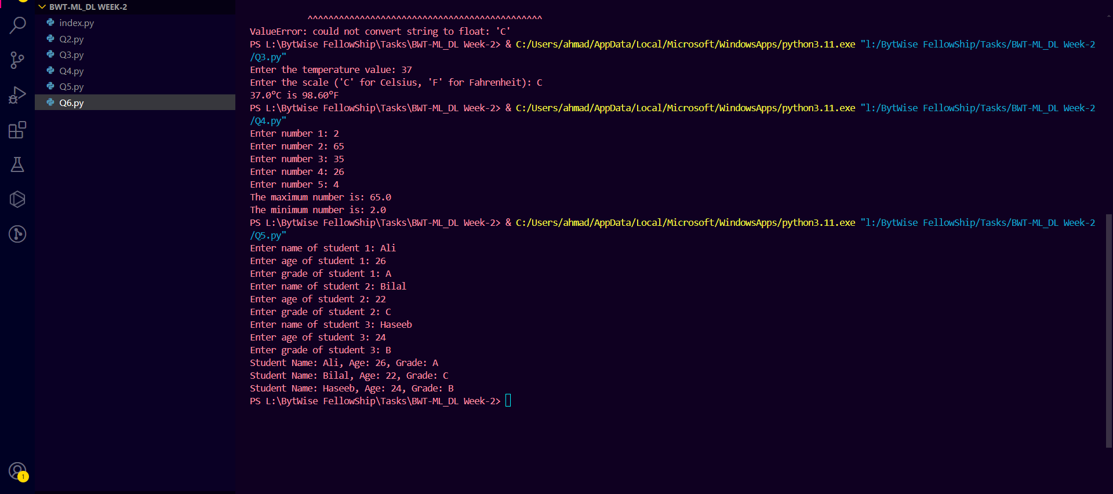

* **Updating Inventory**

**Approach**

We created a function named update_inventory to update an inventory dictionary by adding or removing specified quantities of items. The function ensures that item quantities do not fall below zero. We then initialized an inventory dictionary, prompted the user to update quantities for 3 items, and displayed the updated inventory.

**Logic**

* Check if the item is in the inventory and update its quantity.
* Ensure that the quantity does not go below zero.
* Prompt the user for item updates and apply them using the function.

